**SPI COMMS**

Node MCU schematic

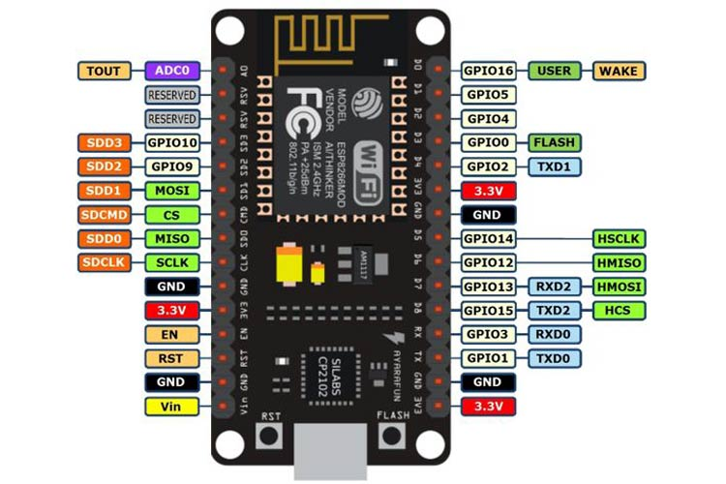

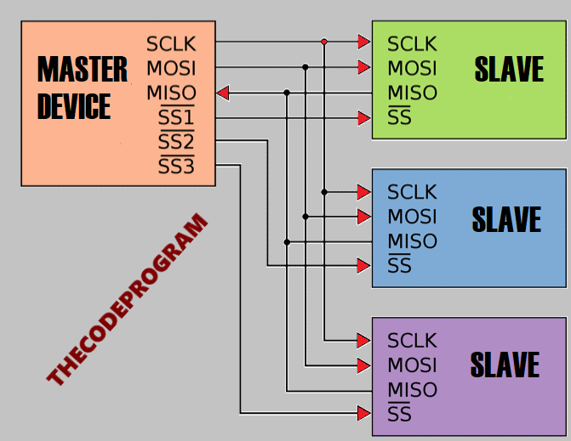Controller to controller connection schematic

* Each subcontroller has 2 neighbourly routes to complete the circular network topology